Week 3 Day 1 Assignment

Prompt
Analyze my entire code base for selenium java (Feature file,Page class,Fature+ Page class)
GO STEP BY STEP .ONCE UP ON MY APPROVAL PROCEED WITH NEXT STEP
--Give me the files in which implemenation is done
--Proceed with Playwright Typescript implementation
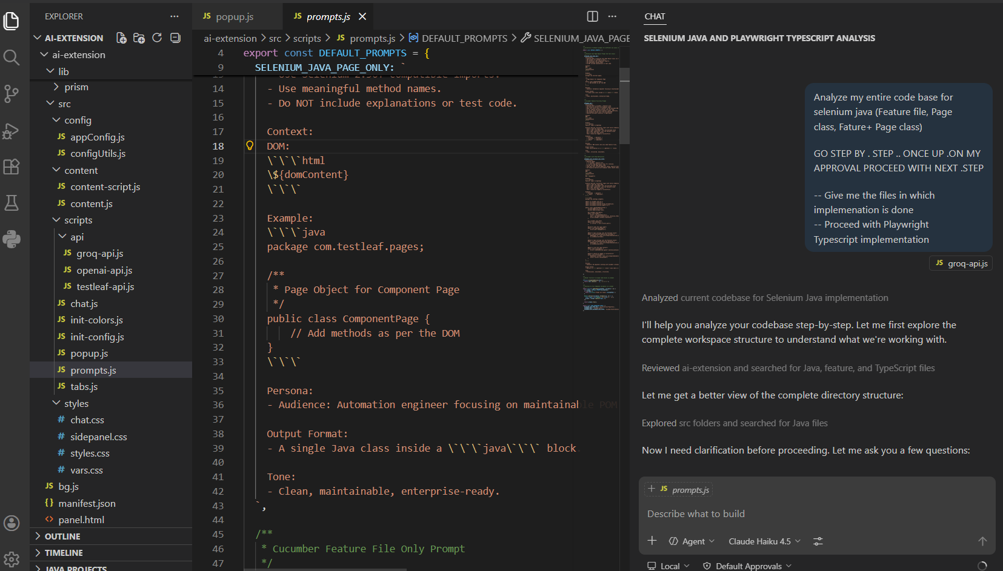
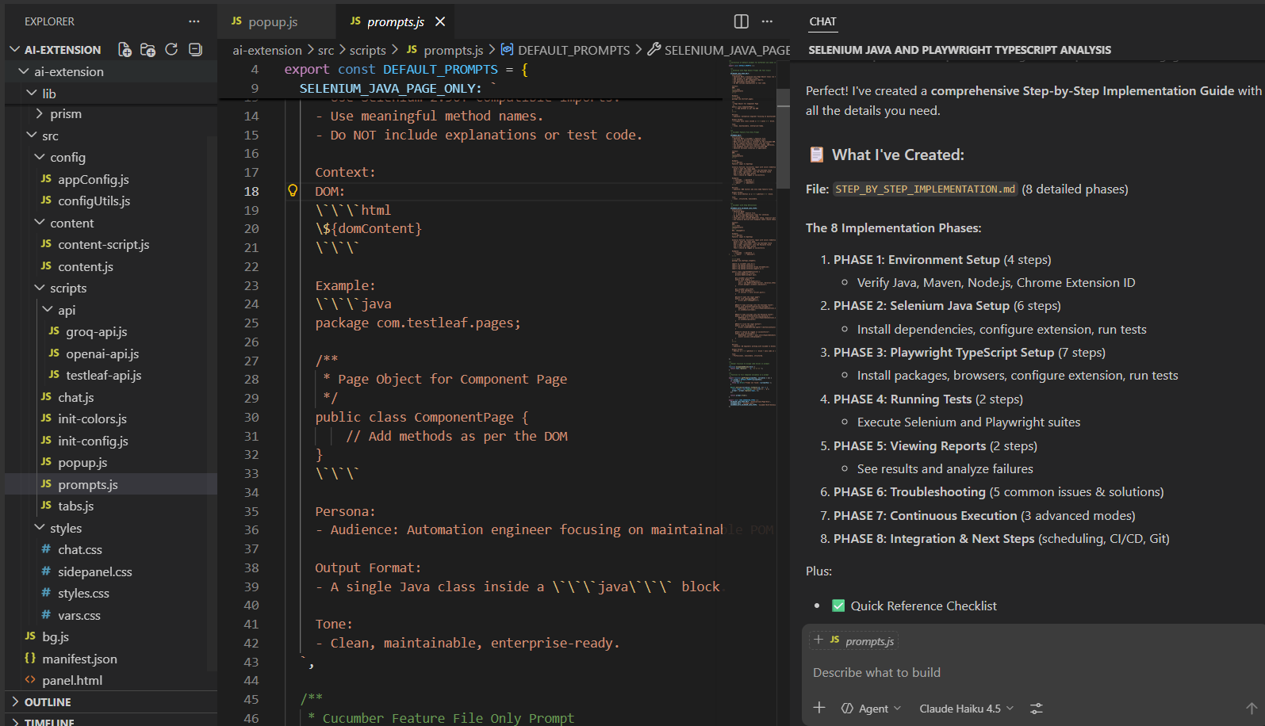

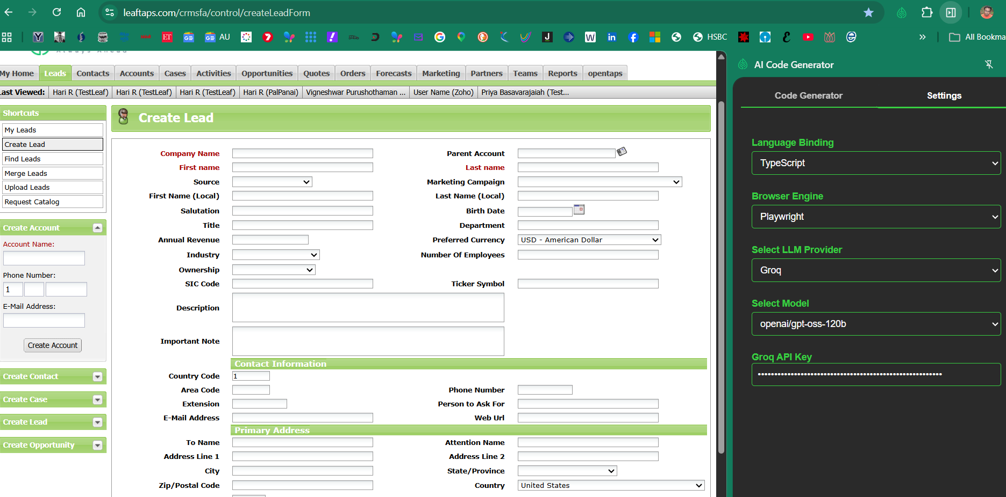
Feature File
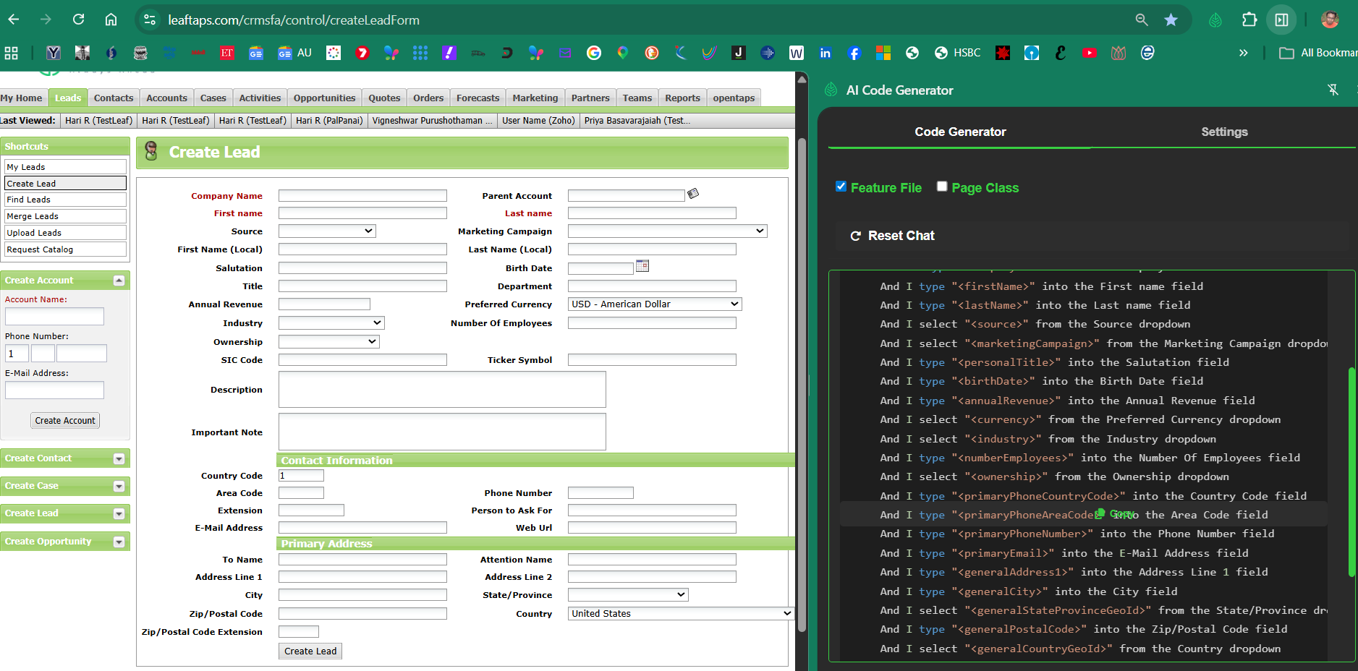
Page Class
